**What are Chatbots?**

A chatbot is an artificial intelligence (AI) software that can simulate a conversation (or a chat) with a user in natural language through messaging applications, websites, mobile apps or through the telephone.

**Building a Chatbot step by step**

* Scope of Work: Order details, revenue-related doubts
* Chatbot Platform Selection: Dialogflow, Rasa, Amazon Lex
* Dialogflow setup Define intents, contexts & fulfillment: intents:” order”,” revenue-related” ; Fulfillment: Create a webhook that can connect to a backend to know the services
* Build Backend: A backend is connected to our answers database FastApi/Flask/Django/Node.js.
* Website Integration: Integrate the chatbot on fmssolutions.com website.

**Dialogflow**

* Offer powerful NLP capabilities out-of-the-box.
* Relies on Google’s vast training data.
* Cloud-based solution.
* Limited customization options.
* Provides easy integrations with various platforms and channels.

**Intent**

The intent is a mapping between what the users say and the action that will be taken by a chatbot.

**Entities**

The common fields which we will be able found in our sentences.

**Fulfillment**

It connects the integration to the backend.

**Backend**

**NodeJS** and Dialogflow connected and the the data we are getting in the above postman format.

**Frontend (ReactJS/Redux)**

We get the data from the node js with the redux store, action, dispatch we shown the data we are getting in the chatbot bot format .

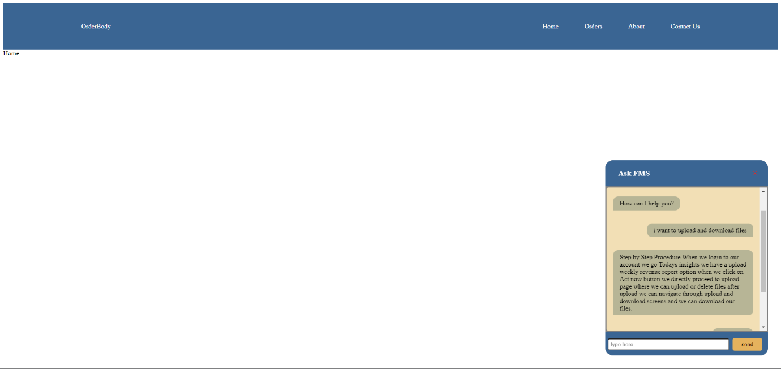

We have to change the css we make it look nice.